Adil Ahmed

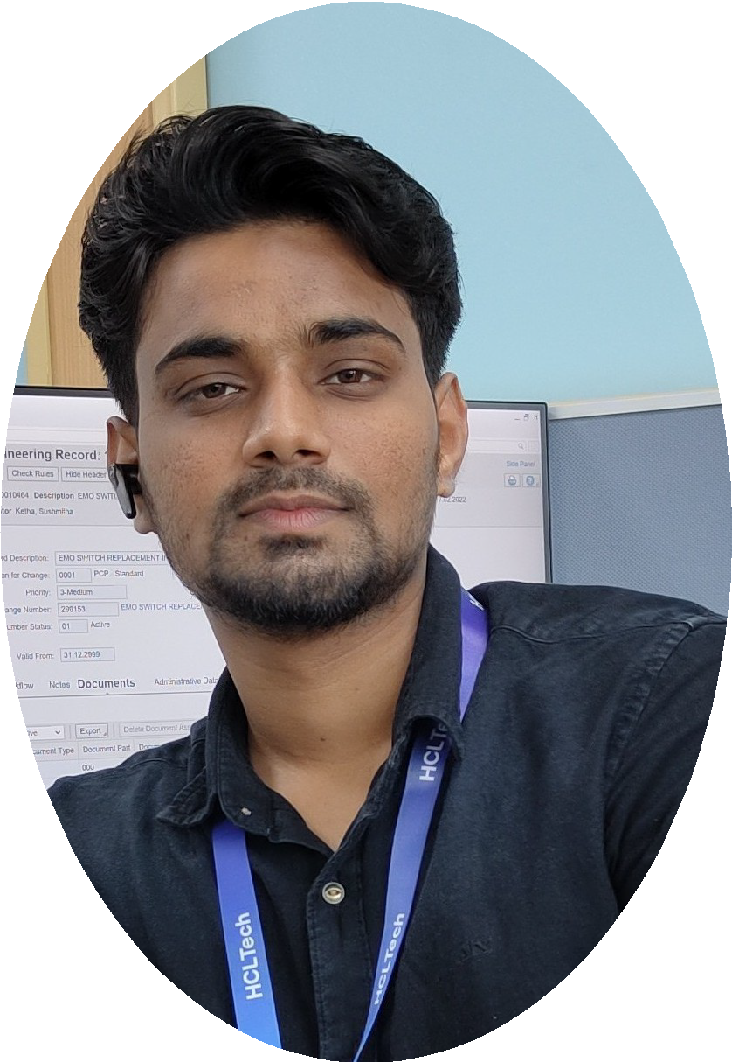

Full Stack Java Developer

**+91 8105880167** [**adilahmed0998@gmail.com**](mailto:adilahmed0998@gmail.com) **Bangalore-560105, Karnataka** [**www.linkedin.com/in/**](http://www.linkedin.com/in/) **adillahmed** [**www.github.com/Adil-Ahmed0998**](http://www.github.com/Adil-Ahmed0998)

# SUMMARY

Aspiring Full Stack Java Developer with a comprehensive 6-month training in web application development and Java programming. Eager to apply newly acquired skills in developing cloud-based web applications and solving real-world challenges. Proficient in back-end development and enthusiastic about contributing to innovative software projects. Committed to delivering results and continuously enhancing technical expertise.

# KEY SKILLS

* **Software Development • Web Application Development • Technical Analysis**
* **Object-oriented Programming • Process Optimization • Project Management**

# TECHNICAL SKILLS

**Languages:** HTML, CSS, JavaScript, Bootstrap, Java

**Frameworks & Libraries:** AngularJS, Hibernate, Spring Boot(Java), Spring(Java),MVC

**Databases:** MySQL

**Operating Systems:** Windows

# EDUCATION

## Master's in Full Stack Java Developer

**Simplilearn Certified in partnership with HIRIST & HackerEarth**

**Course Modules:**

* Object-oriented Java Programming: Data Structures and Beyond | Java Web Pages and Database Management
* Spring MVC and Advance Java Programming | Frontend Web Application Development | Web Application Testing and DevOps

## Bachelor of Technology in Mechanical Engineering Reva University, Yelahanka-Bangalore

* **CGPA:** 7.8/10.0

# CERTIFICATION

## Certification in Bachelor of Technology

**Certification in Full Stack Java Developer Master Program**

# FULL STACK PROJECTS

* **Project 1: Flyaway Airline Booking Portal | Tech Stack: Java, Java EE Servlets, JavaScript, MySQL, GitHub**
  + Coordinated with UX team to develop airline booking portal that generated 94% user engagement
  + Analyzed users' journey and modified existing portal to improve sig up rate by 13%

Apr '22 Delhi, IN

May '22 Bangalore, IN

Jul '22

* **Project 2: Medicare Web Application for Ordering Medicines of Different Categories| Tech Stack: Java, Spring-boot, JSP, JavaScript, Bootstrap, MySQL, GitHub**
* **Engineered** a Medicare web app (HTML, JSP, Spring Boot, GitHub) enabling user sign-in, efficient product search, and secure payments
* **Empowered** administrators with product management capabilities, including addition and deletion
* **Project 3: Kitchen Story (an E-commerce portal) | Tech Stack: HTML, CSS, JavaScript, Bootstrap, AngularJS, GITHUB**
  + **Engineered** an **admin login page** with the capability for administrators to **securely change passwords** after login
  + **Implemented** an intuitive **food item management system** that allows administrators to **add or remove food items** efficiently, resulting in a **50%** reduction in time spent on item management**, Enhanced user experience** by integrating a **search form** on the homepage, enabling customers to effortlessly **browse and purchase food items**, leading to a **20% increase in user engagement**

# PROFESSIONAL EXPERIENCE

## Graduate Trainee Engineer - HCL | [Bangalore] | [Nov,2022]

**Completed Full Stack Java Developer Certification course.[Simplilearn] [Nov'23]**

Nov '22 - Present

Delhi, IN

# ADDITIONAL INFORMATION

* **Hobbies & Interests:** Photo Editing, Reading Novels, Music, Cricket, Badminton
* **Languages**: English, Hindi, Kannada, Urdu, Arabic